Phase 4 Sprint 1 Planning

## Know the end from the beginning

* Sprint Ends April 14th
* This Sprint is going to take about 25 hours to complete
* We present our project on April 14th at 10:50
* Pick a metric to evaluate each other on during the retrospective
* For sprints 2 & 3: List 1 item from your retrospective that you said you were going to do better at that you are going to focus on this sprint.
* Brody Larsen is Scrum Master
  + Johnathan Kunz
  + Brody Larsen
  + Chris Winwood
  + Kosta Sergakis

## Fill out details for each story

* For the start of the First sprint we have no leftovers from the last sprint/phase.

For our final sprint we are planning to do the following

* Replace the Lorem Ipsum with real words/substance
  + This should be a small task
  + We used lorum Ipsum to add filler content, we need to replace with “real” content
  + We need to make sure all the Lorum Ipsum is gone. Our customer wont be happy if there is some left.

Tasks

* + The main page, and the story page still has lorum ipsum
* Check if customer is 18 years or older
  + This is a small task
  + We need to add an if statement in our customer creation logic to get if the customer is 18+.
  + If a customer creates an account successfully and they say they are 10, then the check was unsuccessful.

Tasks

* + When the customer submits their info, add an if statement to make sure the “age” box has a number bigger or equal to 18.
* If the customer is logged, there name needs to be displayed on the page
  + This is a small task
  + The customer’s name needs to be on display on the page so they are logged in.
  + The name needs to be displayed in the top right-hand corner of the page.

Tasks

* + Add an if statement on the html pages to check if the viewer of the website is logged.
  + If the if statement is true display the given name of the customer
* Update Documentation
  + This is a large task
  + We have done many more things than we originally planned on doing. We need to add that stuff to the documentation

Tasks

* + Identify what documents need to be updated
  + Identify what things are different from when we began to where we are now.
  + Update the documents with the new info
* Multiple Pages of Tools
  + Medium task
  + Right now all the tools display on one page, if the number of tools exceeds 10 tools, we want all the tools to be broken up into a list of pages with 10 tools on each page.
  + The number of pages depends on the number of tools on display. If the bike repair tools are on display, we don’t need multiple pages because there are only 4 tools in that category.

Tasks

* + Create logic that detects if the number of tools listed on the page exceeds 10.
  + Create logic that finds out how many pages to break up the list into.
* User Manual
  + This is a large task
  + We needs a manual to describe how the website is navigated.
  + There is the possibility that we have to document how the code works.

Tasks

* + Write about how each page works
  + Write about how each page connects to one another.
* Create a user portal
  + Medium task
  + We want to create a webpage where the logged in customer can see there rent history, there financial info and personal info.

Tasks

* + Create a webpage that allows the customer to change their personal info, look at their tool rental info, and their credit card info.
* Checkout time limit on Tools
  + Medium task
  + The customer is only allowed to checkout a tool for a week at a time. We need to add logic to announce to the customer when the tools are to be returned and send an email to remind them that tools are due tomorrow. If the tools are late, we need to alert the employees that the tool is late.
  + On the 6th day of tool rental, the customer will get a reminder email if the tool is still checked out, reminding them that the tool is due tomorrow. If the tool is past due the customer will get an email telling them the tool, they have checked out, is due.

## Artifacts

* If we have time, we will see about encrypting the passwords on our database
* If we have time, we try to keep track of the customers monthly payments to see if they even paid.
* We never got around to hosting our website on Amazon Web Services.

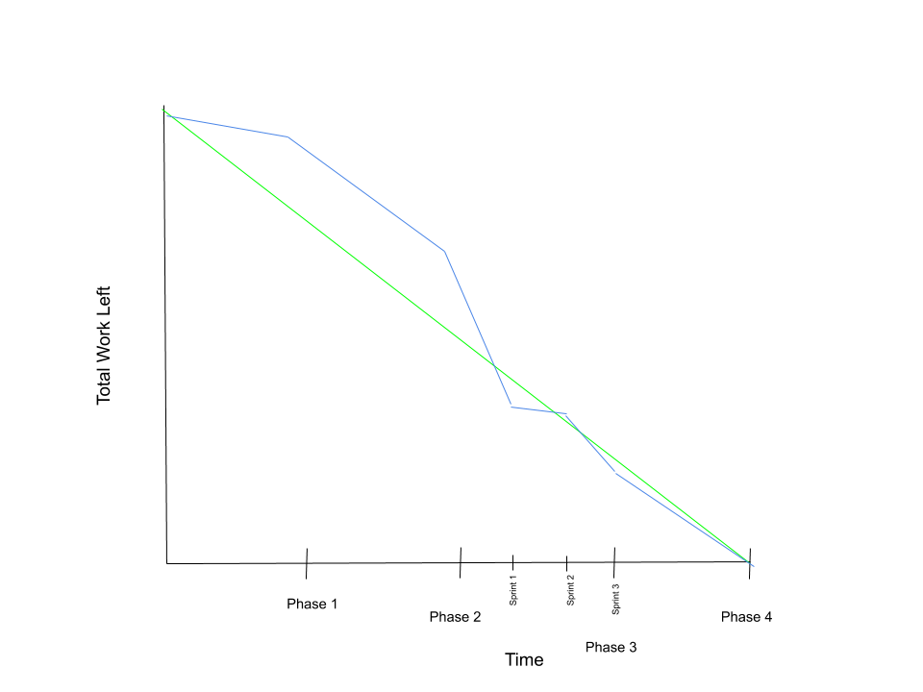

Burndown Chart

